Recording your Visits
To ensure you are correctly credited with all your volunteering hours, you must record both your
Arrival and Departure each time you visit your school.

To record your visits you need to scan the School QR code, which will be clearly displayed in the school reception area.

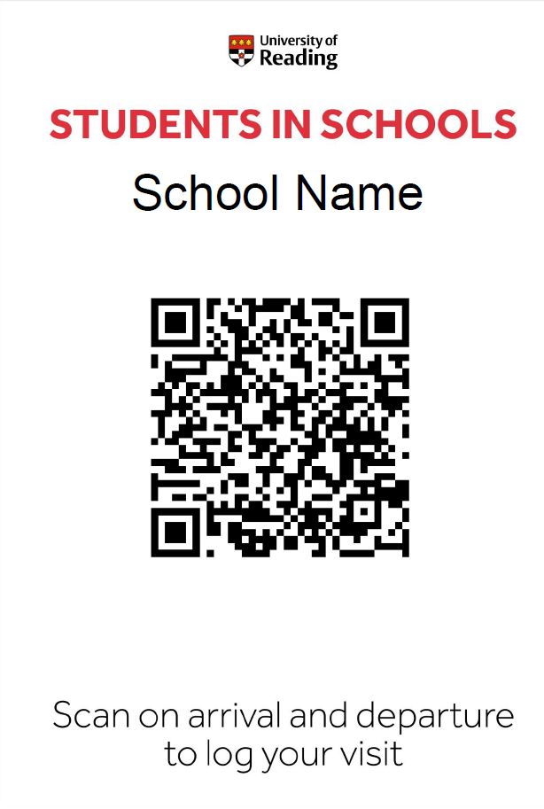
Once you have scanned your school code with your mobile phone please follow the on screen instructions.

NB It is really important that you log both In and Out. Forgetting to log out may result in you not being credited correctly for your visit.

On Arrival
Scan your School’S QR Code
NB You may be asked to enable cookies on your mobile phone for this to work

 | 1 – Select Arrival |  |  | 2 – Login with your 8 digit student ID number
 | 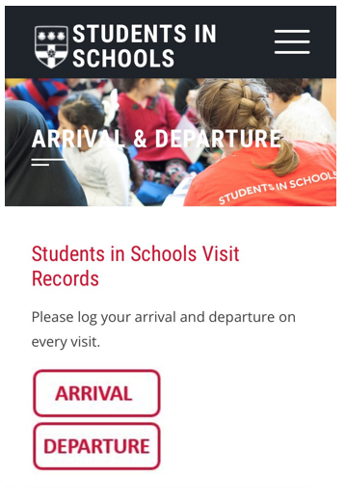 |  |  | 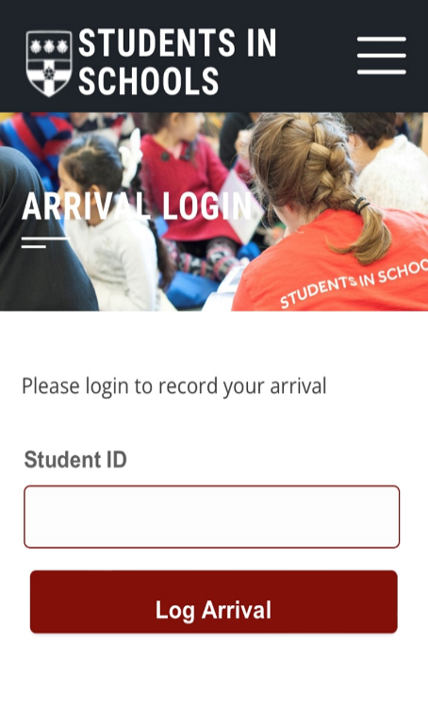
 | 3 – Confirm your arrival |  |  | 4 – An Arrival Confirmed message will be displayed
 | 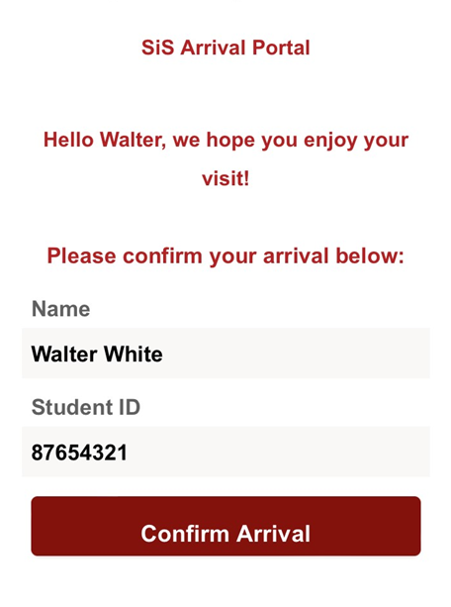 |  |  | 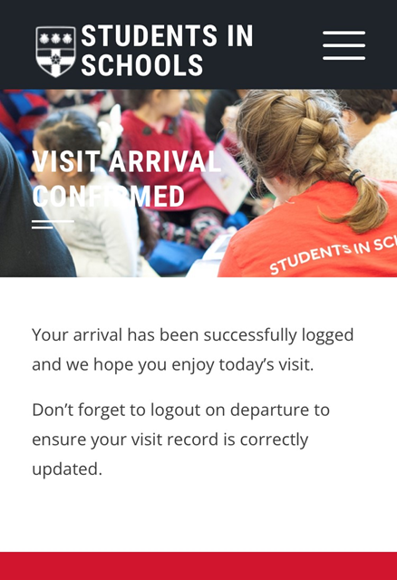
On Departure

Scan the QR code, select Departure and login with your Student ID number.
1 - Click on the kebab menu to the side of your name | 2 - Select record, correct visit option, then Update Visit
3 - Your current visit details will be displayed. ‘View your Full Record’ will show a complete list | 4 - All correctly logged visits will be displayed including total number of visits and hours to date
You will also receive an email confirmation of your visit

