Guidance for Report 2 Completion – March 2026

Please find the information about the upcoming Report 2s below. The RPTs will be contacted today so they are proactive in leading this process over the next fortnight.

On Friday 20th March (ten school days from now), the RPTs’ Report 2s are due.
In this email I describe share a detailed overview of the process for completing these reports; however, I don’t want this to overcomplicate what is actually a simple and intuitive process. If you have been involved with the programme during Placement A or in previous years, there is nothing to follow which is new and all instructions are baked into the Report template.
In summary this means:
- RPT to initiate the Report process by completing sections in green on their Report template.
- RPT and Mentor to discuss Report during Mentor Meeting, using Assessment Framework.
- Mentor to complete Mentor sections of Report. Mentor to share with ITTCo.
- ITTCo to complete ITTCo sections of Report. ITTCo to send to pgcesecondary@reading.ac.uk, RPT and Subject Lead.

Context of Report 2
The report is designed to be completed efficiently and simply, building on the assessment of the Placement A Mentor and ITTCo in the Provisional Report 2, in order to reflect the fact that RPTs will only have been on placement for 17 school days.
The RPTs must be assessed against the Assessment Framework criteria as set out in the attachment to this email. Please only use this criteria as the basis for judgements. We ask that all mentors discuss this with their RPTs in their mentor meeting this week so that there are no surprises.

Completing Report 2
The RPT will initiate the reporting process by completing the sections coloured green on the report, and then share the document with their mentor.
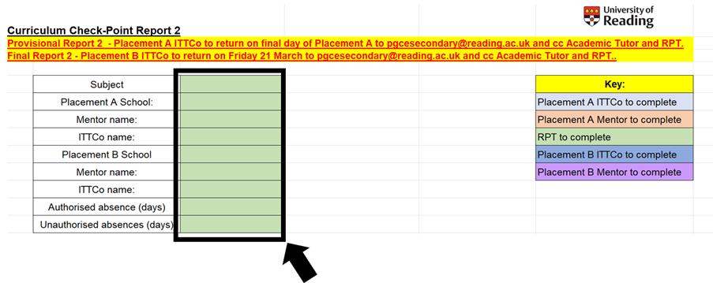

The Key at the top of the report indicates which sections the Placement B Mentor needs to complete (purple) and which sections the Placement B ITTCo has to complete (dark blue).
The Placement B Mentor and ITTCo are not assessing the RPT for the whole of the module. The Placement A Mentor and ITTCo have already completed the Provisional Report 2, which means that the role of the Placement B Mentor and ITTCO is to assess whether they:
- agree with the judgement of the Placement A Mentor and ITTCo. In our experience, the attention and thought put into the Process by Placement A Mentors and ITTCos mean this will be in the VAST majority of cases.
- have already seen evidence that the RPT has made progress since the Provisional Report 2. This is great to see as the RPTs are thriving in a new context, with new colleagues and pupils, following a coherent transition.
- have not yet observed the practice displayed during their Placement A. This does not necessarily mean that the Mentor and ITTCo should change the assessment from them ‘meeting’ the criteria to ‘not meeting’ as they might not yet have had the opportunities to meet, in which case ‘Yes with comments’ would be appropriate.

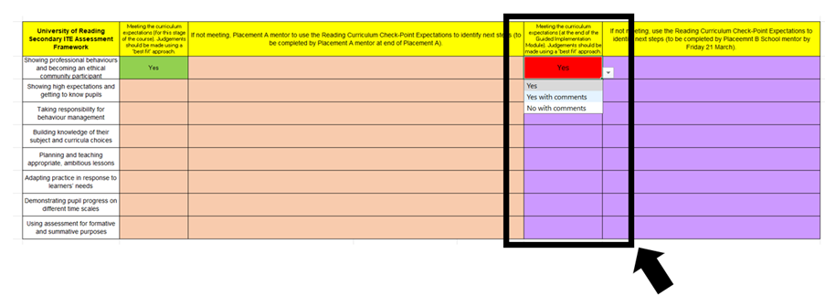
The Placement B Mentor has three choices for each of the themes in the Assessment Framework:
1. Yes – the RPT has already shown evidence that they have met/exceeded the criteria. (Please note, that the ‘Yes’ box is coloured red which is not ideal for ‘positive optics’.)
2. Yes with comments – the RPT has generally shown evidence that they have met/exceeded the criteria, but you want to highlight some areas they must work on once they are more settled in your school.
3. No with comments – the RPT has not met the criteria for this stage of the programme. If ‘No’ is selected for ANY of the either sections, the Mentor must contact the relevant Subject Leader in advance to inform them that this is their recommendation for the report.
- Please note that these reports are designed to be completed efficiently - if the Placement B Mentor agrees with the judgement of the Placement A Mentor, then they need only indicate in the drop-down menu that they agree and there is no need for comment.

All Reports will need to be sent by the Mentor to the ITTCo, for a final summative update for the start that the RPT has made to the school. For this we strongly encourage professional behaviours to be referred to explicitly, as it can sometimes be difficult for RPTs to evidence these at the end of the programme.
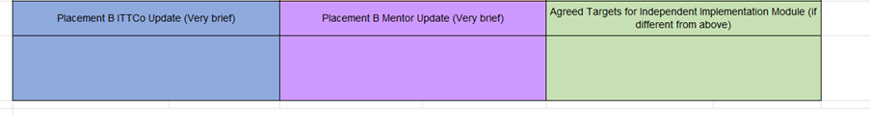
When making the overall recommendation for whether the RPT has met/exceeded the assessment criteria for this stage of the programme, please can ITTCos be hyperaware that:
- If the RPT has any 'No's on their report then they must be assessed as 'No' overall.
- If the RPT is assessed as 'No' overall, the Mentor must have communicated this with the Subject Lead. Please can ITTCos check with Mentors that they understand the consequences if they send the report to you with any 'No's.
This process is flagged in the final section for ITTCos to complete:
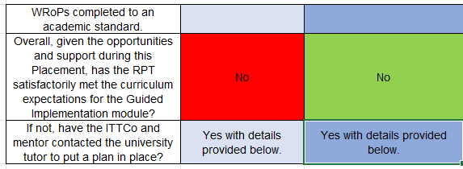
The ITTCos will submit these Reports by the end of Friday 20 March. The RPT must be cc-ed, and can we ask that the relevant Subject Leader is as well please.

(In previous years, RPTs have become distressed if there are delays in the submission of their reports, so can we request that if there is likely to be a delay this is very clearly communicated with the RPT as well as the university.)

If you have any questions about an individual RPT’s report, please raise with the relevant Subject Lead at the earliest opportunity, and inform the University’s admin email address if reports will be delayed for whatever reason: pgcesecondary@reading.ac.uk.

Again, I hope this helps and isn't overcomplicating things. As ever the key things to ensure are: the actual criteria is used, there are no surprises and, where there are issues, there is communication between Mentors/ITTCos/Subject Leads as early as possible.
Let us know if you have any queries or concerns, or of course if your recommendation is going to be that the RPT has not met one (or more) of the assessment criteria.

