The Primary PG ITE Music enrichment trains students in:

Primary PG ITE Music Enrichment 2025-26

Tutor: Dr Rebecca Berkley, r.m.berkley@reading.ac.uk

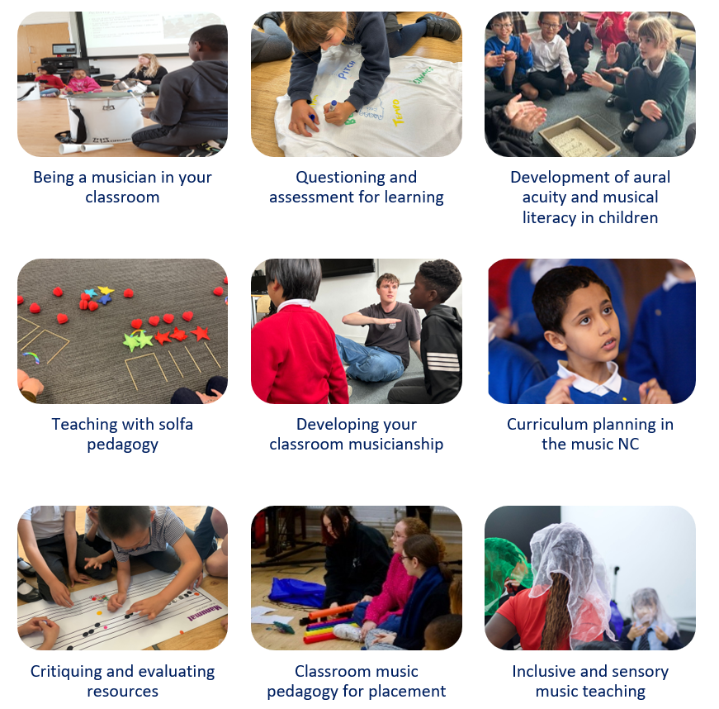

Music Enrichment aims and purpose

This enrichment programme seeks to facilitate students to be a musician in their classroom. Students learn how to use their musical skills in the primary classroom to teach creative and practical music lessons to children. Training in university focuses on building students’ musicianship skills and aural acuity alongside their pedagogical and curricular understanding. Students try out classroom ideas for teaching composing, performing and listening through practical music making. Students learn foundation level solfa pedagogy - a kind of musical phonics system to support children in develop musical literacy – alongside techniques of leading singing and managing creative music making in the primary classroom.

1.1 What are student teachers learning to do in this Music Enrichment?

By the end of this year, it is expected that students will be able to:
- Plan, deliver and appraise individual and sequences of music lessons integrating classroom performing, composing and listening on school placement, assessing how to teach effectively to support children’s musical learning
- Create practical resources for music teaching from a range of different published sources, critiquing their fitness for purpose in the primary classroom for inclusive music teaching and learning
- Demonstrate competence in classroom musicianship skills based on solfa pedagogy appropriate to teaching primary aged children
- Critically appraise a school’s music curriculum considering how learning is sequenced through performing, composing and listening activities, and inclusive music teaching is available for all children

University training

In the Music enrichment sessions, students are exploring:

- Developing classroom musicianship skills to lead practical music making in the primary classroom
- Classroom performing, improvising and composing with voices and instruments
- Curriculum planning in the music NC
- Inclusive and sensory music teaching
- Leading choral singing in the classroom
- Understanding how to facilitate the development of aural acuity in children through practical musicianship, singing and chanting, moving to music and the development of musical literacy
- Repertoire for classroom practical music making in composing, performing and listening
- Critiquing and evaluating published resources for classroom teaching
- Questioning, assessment for learning, errors and misconceptions in musical learning in young children
- Teaching solfa musicianship pedagogy in the Music National Curriculum

2.1 Schedule of Music Enrichment University training sessions
Date | Session | Topic
12.9.25 | Introduction | Introduction to the Music Enrichment  Classroom Musicianship – Practical learning in music in the primary classroom
18.9.25 | 1 | Classroom Musicianship  Active listening and games based musical learning
10.10.25 | 2 | Classroom Musicianship  Innocent ears and contextual musical analysis
13.1.26 | 3 | Classroom Musicianship  Creative improvising and composing
15.4.26 | 4 | Classroom Musicianship  Inclusive musicianship pedagogy – musical literacy for all children
26.5.26 | 5 | Classroom Musicianship  Refining music pedagogy

3. Teaching music on placement
Please help your student teacher to teach music whilst on placement. Help your trainees by:

Meeting with the music co-ordinator - Please organise time meet with the music co-ordinator so they can discuss music teaching in the school, observe teaching, read the school music plan and understand the sequence of learning from YR - Year 6.

Teaching music lessons - Please give students classroom time to try out teaching, ideally a sequence of 3-4 (or more) x 30 minute music lessons over consecutive weeks. If your school uses an online scheme of work, then please allow students to try out the practical approach we are modelling in University so they can explore using their practical musicianship skills with the children.

Access to practical resources for teaching - Please give students practical support in finding music resources to teach with, e.g. the percussion trolley, music books or teaching resources, and classroom instruments.

Observing their music teaching - Please use the Music Good Practice Guide as a prompt when observing students. This outlines what to look for in a good music lesson with plenty of practical activity for children.

