
Institute of Education

Primary PG ITE Mentor Handbook 2025-26

Contents
1. Introduction 2
2 Key Information 2
2.1 Key university staff 2
2.2 Glossary of terms/acronyms 2
2.2 Course Structure 4
4 Roles and Responsibilities 6
4.1 The Supervising Tutor 6
4.2 The ITTCo 6
4.3 The Mentor 7
4.4 The Lead Mentor 8
5 Being a Reading Partnership Mentor 8
5.1 Definition of a Mentor 8
5.2 Weekly mentor meeting 9
5.3 Observation and feedback 10
5.4 Assessing Progress 11
5.5 Support and difficulties 11
5.6 Certification and development as a mentor 12
6 Appendices 13
Appendix A: Mentor Training Curriculum 133
Appendix B: Observation Summary Form 15

Introduction

‘The human relationship and the conversational learning between mentor and mentee is essentially about learning in a social context and the learning which takes place, because it is social, externalised and internalised, is of a higher order. Coaching and mentoring then reach the parts that other forms of learning just cannot reach’ (Gray et al, 2016, p109​)
Welcome to the University of Reading’s guidance for Reading Partnership Mentors (RPMs) on the Primary PG ITE programme. RPMs are a vital component of beginning teachers’ development, and it is our hope that this handbook will provide a comprehensive overview of the RPM’s role. The role of the RPM is a highly valuable one and we want to take this opportunity to thank you for your support and guidance of our trainees.
To support you in your role, we have developed a research-informed curriculum for mentors which its value, and develops each RPM’s capabilities as a mentor and competence in supporting each RPT to thrive. Mentor training materials, as well as documentation you will need, can be found on our Mentor Hub website here:
Primary Postgraduate Initial Teacher Education (Primary PG ITE) Mentor Training – University of Reading Mentor Hub
It is vital that you access this website as it will direct you to the compulsory and optional training relevant to whether you are a new or experienced mentor, and whether you wish to achieve mentor certification.

Key Information

Key university staff

Name | Role | Email
Lead Mentor | Gill Martin | gill.martin@reading.ac.uk
Scarlett Murphy | Programme Director, Primary PG ITE, Deputy Head of ITE | s.l.e.murphy@reading.ac.uk
Georgia Aspinox | Assistant Director | g.aspinox@reading.ac.uk
Phil Smith-Stevenson | Assistant Director | p.smith-stevenson@reading.ac.uk
Programme Admin | Suzannah Newton | pgceprimary@reading.ac.uk

2.2 Glossary of terms/acronyms

AoP | Assessment of Progress | This document will follow the RPT through the year, providing a tracker of their progress across placements.
AT | Academic Tutor | Each RPT will have an AT who is a member of university staff. Their role is to support the RPT pastorally and academically.
BB | Blackboard | The students virtual learning environment where they will find their learning materials, proformas, timetables etc.
IR / PR | Interim Review / Progress Review | During each placement, there will be an Interim Review meeting  mid-way through and a final Progress Review meeting towards the end. This will be attended by the RPT, the RPM and the trainee’s Supervising Tutor.
ITTECF | Initial Teacher Training and Early Career Framework (combines the former Core Content Framework and the Early Career Framework) | This framework outlines the key knowledge, skills, and behaviours trainee teachers should learn about and develop during training.
ECT | Early Career Teacher | Qualified teacher in the first two years post gaining QTS.
ITaP | Intensive Training and Practice | Teacher training must include elements of intense training and practice which focus on foundational aspects of teaching, such as behaviour management. An ITaP includes training at the university, followed by practising this learning on placement.
ITE | Initial Teacher Education | Initial Teacher Education (ITE) provides the training and professional preparation needed to become an effective teacher and to be recommended for qualified teacher status (QTS) – in this case by the University of Reading.
ITTCo | Initial Teacher Training Co-ordinator | Member of school staff who has oversight of teacher training.
LHT | ITTECF ‘Learn how to…’ statements | Objectives on the ITTECF about teaching skills.
LT | ITTECF ‘Learn that…’ statements | Objectives on the ITTECF about knowledge that teachers need.
LM | Lead Mentor | Member of university staff who supports mentors – in this case Gill Martin.
LPR | Lead-Partner Recruited | Students who have been recruited by our local lead partner schools, rather than the university.
PD | Programme Director | Member of university staff who leads the programme – in this case Scarlett Murphy.
PGCE | Post-Graduate Certificate of Education | Qualification that leads to QTS and masters credits.
PgCE | Professional Graduate Certificate in Education | Qualification that leads to QTS.
PS | Professional Studies | Training provided by the ITE provider about teaching skills eg lesson planning.
RPM | Reading Partnership Mentor | You!
RPT | Reading Partnership Teacher (trainee) | The students working towards QTS.
ST | Supervising Tutor | Each RPT will have a ST who is a member of university staff. Their role is act as a link between the university and school. They will attend progress review meetings, monitor the RPT’s e-portfolio and should be the first point of call for questions about placement.

Course Structure

Date |  | Monday | Tuesday | Wednesday | Thursday | Friday
1.9.25 |  | LPR in school | LPR in school | LPR in school | LPR in school | LPR in school
8.9.25
15.9.25 |  |  |  | Mentor training (online)  4-5:30pm
22.9.25 | Induction | Online mentor check in
29.9.25 | Induction | ITAP Professional Relationships  Uni | ITAP Professional Relationships  Sch |  |  | Masters
6.10.25 | Group
13.10.25 | Group | ITAP Behaviour  Uni | ITAP Behaviour  Sch | ITAP Behaviour  Sch
20.10.25 | Whole lessons | Interim progress review 1 (online)
27.10.25 |  | Masters PM |  | Masters
3.11.25 | Whole lessons | Interim progress review 1 (online) |  |  |  | Interim Review form due
10.11.25 | Whole lessons | ITaP Modelling  Uni | ITaP Modelling  Sch
17.11.25 | 20%
24.11.25 | 30%
1.12.25 | 30% | ITaP Inclusion  Uni | ITaP Inclusion  Sch
8.12.25 | 40% | Final progress review 1 (f2f)
15.12.25 | 40% | Final progress review 1 (f2f) |  |  |  | Submit AoP to BB
22.12.25 | Christmas
29.12.25
5.1.26
12.1.26 |  |  |  | Mentor training (online)  4-5:30pm
19.1.26 | Induction | Online mentor check in
26.1.26 | 20% | ITaP Inclusion  Uni | ITaP Inclusion  Sch
2.2.26 | 30%
9.2.26 | 40% | ITaP Modelling  Uni | ITaP Modelling  Sch | Interim progress review 2 (online)
16.2.26
23.2.26 | 50% | Interim progress review 2 (online)  Friday 27th – Submit AoP to BB
2.3.26 | 60%
9.3.26 | 80% | Final progress review 2 (f2f)
16.3.26 | 80% | Final progress review 2 (f2f)
23.3.26 | 80% | Final progress review 2 (f2f)  Friday 27th – Submit AoP to BB
30.3.26 | Easter
6.4.26 | Easter | BH
13.4.26 |  |  |  | Mentor training  (online)  4-5:30pm
20.4.26 | Induction | Online mentor check in |  |  |  | ITAP Professional Relationships  Sch
27.4.26 | 20% | ITAP Professional Relationships  Uni | ITaP Behaviour  Uni
4.5.26 | 30% | BH | ITaP Behaviour  Sch
11.5.26 | 50%
18.5.26 |  | Interim progress review 3 (f2f)  External Examiners – Thursday and Friday
25.5.26 | Half Term | BH
1.6.26 | 80% | ITaP Diversity Uni | ITAP Diversity Sch | ITAP Diversity Sch | Interim progress review 3 (f2f)
8.6.26 | 80% | Interim progress review 3 (f2f)  Friday 12th June – AoP to BB
15.6.26 | 80%
22.6.26 | 80% | Final progress review 3 (online)
29.6.26 | 80% | Final progress review (online) |  |  |  | Final celebration on campus  AoP to BB

Autumn / Summer Placement
Spring contrasting placement
ITaP
University training
Masters

4 Roles and Responsibilities
The RPT is supported in their development principally by three professionals, as set out here:

4.1 The Supervising Tutor
The ST (University staff) quality-assures training and progress, supports mentors, attends interim and final Progress Review meetings, and monitors the e-Portfolio. They are your first point of contact for placement queries.

4.2 The ITTCo
The ITTCo is responsible for organising and quality assuring Initial Teacher Training in the school and are involved in mentor selection. Their primary responsibilities are:
- To prepare and implement a policy for ITE within the school.
- To manage and support the team of mentors, ensuring that they understand the demands of their role and facilitate the sharing of good practice by meeting with them at intervals to share good practice and monitor the progress of the RPTs across the programme.
- To support the RPTs in their implementation of the University of Reading’s ITE curriculum.
- To introduce the RPTs to the ethos and working procedures of the school and to key members of staff.
- To provide training for RPTs on safeguarding and on the relevant school policies, completing all inductions.
- To arrange for each RPT to be attached to a class and work alongside the class teacher (if not the mentor).
- To observe each RPT and give written feedback on the lesson.
- To monitor and contribute to the assessment of the RPTs’ progress towards the Teaching Standards for the award of Qualified Teacher Status by monitoring the quality of the AoPs completed by Mentors, adding additional comments where appropriate and discussing the reports with the RPTs.
- To support the Quality Assurance monitoring procedures of the PGCE Programme and thereby strive for continual improvement in the quality of both school-based and centre-based training.

4.3 The Mentor

The Reading Partnership Mentor is responsible for supporting, guiding, and coaching the RPT, so that RPTs can develop and flourish in their classroom practice in their school experiences. This involves providing the RPT with an appropriate timetable, attending relevant University training, and meeting with the RPT each week. The RPM adjusts the training programme in school to meet the individual needs of the RPT, liaising with other members of the school to ensure consistency of approach.
Mentors must communicate regularly with their ITTCo, in order to ensure that the Partnership Agreement is being fully implemented, and that the RPT has every opportunity to engage fully with the ITE curriculum.
The primary responsibilities of a RPM are:
- Meet with RPT/s at the start of the placement to begin creating robust and mutually respectful, professional relationships.
- Support the RPTs:
  - Formally, via a mentor meeting once a week, to be recorded on the Weekly Planner (found in the RPTs ePortfolio which the RPT’s will share with the mentor), setting effective and appropriately challenging targets.
  - Informally, with regular opportunity for reflective discussions, encouraging RPTs to identify the positives
- Collaborate with and support RPTs to plan, teach and assess, being mindful of expectations at each stage of training.
- Observe lessons/group work (at least one per week, if possible) and provide constructive written and verbal feedback.
- Support RPTs to use their Learning Timetable as a flexible framework, ensuring they continue to make good progress.
- Support RPTs to meet, and assess them against, the Assessment Descriptors (Autumn and Spring) or Teacher Standards (Summer) by the end of each placement.
- Notify the Supervising Tutor if there are any worries or queries, including where progress is slow and liaise with the RPT, ITTCo and university to arrange Extra Support
- Complete mentor training as outlined in Appendix A

For the mentor, mentoring provides:
- A catalyst to reflect upon one’s own practice
- A way of developing personal and professional skills further
- Opportunities to network with other professionals and enhance professional development
- Job satisfaction and increased self-esteem

4.4 The Lead Mentor
The primary responsibilities of a Lead Mentor are to support RPMs, for example by supporting with struggling trainees.
They may also be involved with:
- Mentor training
- Quality assurance of mentoring via mentoring evaluations, feeding into continued programme development.
- Escalation panels, where RPTs may be considered as ‘Cause for Concern’.
- External Examiner visits and validation exercises.
- Working one-to-one with mentors who are keen to extend/develop their mentoring skills further (if, for example, they have a very able trainee).
- Working in partnership with Programme Directors and school-based ITTCos to carry out their role.

5 Being a Reading Partnership Mentor

5.1 Definition of a Mentor

There are many definitions of mentoring and different mentoring models. A helpful starting point can be to see mentoring as a professional support, whereby mentoring provides:
…a one-to-one relationship between a relatively inexperienced teacher (the mentee) and a relatively experienced teacher (the mentor), which aims to support the mentee’s learning, development and well-being, and their integration into the cultures of both the organisation in which they are employed and the wider profession. (Hobson, 2016, p. 88)
This is a holistic definition that centres mentoring as a relational process and is explicit in the focus on the mentee’s wellbeing, as well as their development as a teacher.
We know how important mentors are in the establishment of beginning teachers’ professional identity and classroom practice, through the range of support mentors provide to induct them into the profession (Hobson, Ashby, Malderez, & Tomlinson, 2009). This speaks directly to the attributes that we aim for RPTs to develop in their initial training year, to become: Evidence-informed teachers, Compassionate individuals, Pedagogically-skilled practitioners, Creative critical thinkers and Ethical community participants.
It is important that RPMs recognise their role in the development of these attributes, in order for RPTs to become the value-driven, effective professionals who make positive contributions to education that is the programme’s aim.
In addition, RPMs will benefit from their role: the positive impact you will have on their RPTs, the development of your own learning and reflection on your own practice, and seeing the development of your trainees over time (Hobson, Ashby, Malderez, & Tomlinson, 2009).
Through engaging with the training on the Mentor Hub website, mentors will learn about how to be an effective mentor and fulfil the DfE’s mentor standards as outlined below:
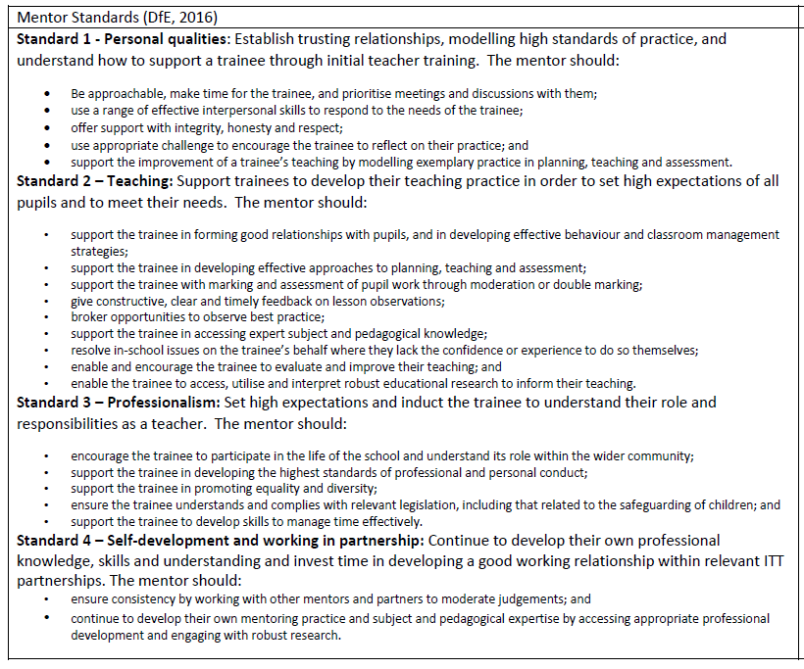

5.2 Weekly mentor meeting

This meeting should be timetabled in for at least one hour each week.
Core structure:
1. Review progress over the latest week (draw on observation notes, pupil work, and formative feedback).
2. Deepen with a focused developmental dialogue on an agreed area of practice (evidence based and linked to ITTECF entitlement/subject knowledge).
3. Plan next steps and agree up to three SMART targets for the coming week (at least one subject knowledge target using the Good Practice Guide).
The remainder of the meeting should cover:
1. Planning the learning timetable for the following week,
2. Working together to identify training priorities and opportunities, informed by the entitlement set out in the
ITTECF
3. Looking back to reflect on progress and achievements informed by feedback from formal and informal
observations, using this feedback to set targets for the forthcoming week
4. Review progress against the Assessment Descriptors / Teachers’ Standards and plan for any specific training
needs
6. Address any personal support needed (e.g. help with personal organisation or time management issues,
anxieties
or concerns affecting training and progress, relationships within school)
7. Maintain an overview of the long-term training plan to ensure that requirements are being met

Record-keeping: the RPT completes and shares the Weekly Planner in the e Portfolio (OneNote). This will be checked weekly by the ST to ensure:
• the RPT’s timetable meets phase expectations and includes PPA (≥20% protected),
• any school based tasks including ITaP tasks are progressing,
• one formal observation and appropriate peer/mentor observations occurred, and
• agreed targets are in place and reviewed.

5.3 Observation and feedback

RPTs should be formally observed once a week by their mentor or ITTCo. The observer should use the Observation Summary Form (Appendix B), and annotate planning against the agreed focus and its impact on pupils’ learning.
Following an observation, the observer and RPT should have a post-observation reflective conversation. Avoid starting with “How do you think it went?”. Instead, begin with “What did you want the pupils to learn?”. Immediately, this question will mean that your RPT’s reflection focuses on the learning of the pupils, rather than their own performance. This has two benefits: it means that they are less likely to fall into a cycle of self-flagellation by criticising their own capabilities and it will open up a deeper conversation about the strategies and decisions that took place in the lesson and their impact on pupils’ learning. Your following discussion is therefore less likely to feel judgemental, as you are both critiquing the dynamic interaction between learning activities and pupils’ engagement and reaction to them (Roberts, 2020, p. 120).
The literature on effective mentor feedback include: being supportive (Martinez Agudo, 2016); showing empathy (Akcan & Tatar, 2010); recognising trainees’ efforts through using praise, which will encourage and motivate them (Rhodes, Stokes, & Hampton, 2004); being sensitive and balanced (Parsloe & Wray, 2000); being goal-oriented (Brandt, 2008).
The REVIEW model of feedback (see next page) has been developed to support Mentors in encouraging RPTs to reflect on their teaching and take ownership of their development. It is important that RPTs seek to understand their practice rather than to imitate role models.
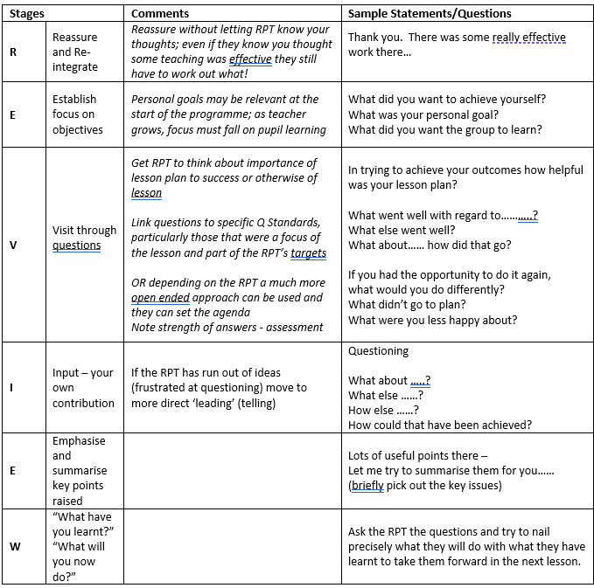

5.4 Assessing Progress
School Experiences are assessed as pass/fail each placement’s final Progress Review meeting which takes place towards the end of the placement. During this, the examples that the RPT presents to support their achievement of the Strands / Teachers’ Standards will be assessed regarding the expectations at that stage of the training process.
As a mentor, you are integral to the assessment of the RPT and will need to complete the Assessment for Progress document (which tracks an RPT’s progress over their training) prior to any review points alongside your RPT, with you both identifying together strengths and areas for development against the Strands / Standards.

5.5 Support and difficulties
Sometimes RPTs have difficulties and may need intervention. Mechanisms for supporting your RPT if they are having difficulties are in place. Please alert their supervising tutor in the first instance and your ITTCo (we require RPMs to indicate on each Weekly Planner that they are satisfied that their RPT is engaging appropriately with the ITE curriculum). Supervising tutors will then advise you on how best to proceed, which may include introducing an Extra Support Form or Cause for Concern. Both plans are designed to be supportive, provided focused targets and strategies to help RPTs overcome any barriers to making progress on the course that they may have.

5.6 Certification and development as a mentor
Mentors who successfully complete the full Mentor Curriculum modules will qualify for Mentor Certification, demonstrating that they can:
- Be effective mentors to Reading Partnership Teachers
- Develop the more generic skills of mentoring that will enable them to enhance their career development
Part of gaining the Mentor Certification may involve being invited to speak at one of our Partnership Mentor Training events. In subsequent years, mentors who have successfully completed all four mentor modules will only be required to complete the 6hrs of ‘core’ refresher training (as outlined in Appendix A).
Mentors may also be interested in taking our Master’s Level mentorship module (EDM190 ‘Developing Mentoring Excellence’ - 200hrs of study; blended learning; 20 M Level credits). Please contact pgecsecondary@reading.ac.uk for further information.

6 Appendices

Appendix A: Mentor Training Curriculum
Core content for all who mentor this academic year, including certified mentors*, per placement
Item | How?
Curriculum and Placement Familiarisation | Live online mentor training prior to the placement, including reading handbook. Please see placement documentation page for these sessions: Placement Documentation
Tutor Visit during placement (Interim / Progress Review) | Agree date with tutor during window – online and face to face
Engagement with mentor bulletins | Emailed out fortnightly
* Please note, certificated mentors are those who gained our new certification in 2024-25 or who held Level 3 certification under our old scheme. Alternatively, if you have completed training as an ECT mentor, or gained an NPQLTD or completed mentor training in 2024-25 with another ITE provider, then you are certificated via that route. If this applies to you, please complete the Prior Learning Form which can be found on the Mentor Hub.
Content for new and non- certificated mentors
Item | How? | ITTECF references (LHT statements)
Module 1.3: Understanding trainee knowledge and development – Meeting your RPT | Scripts using handbook | 8a, 8n, 7l, 3a, 4a, 2a
Module 2.1: Implementing the ITE Curriculum – Target setting and observing | Pre-recorded video | 8b, 8f, 8j, 8p, 8q  1a, 1b, 1c, 1e, 1f, 1g, 1h, 7a, 7b, 7d, 7e, 7f, 7g, 7h, 7i, 7j  3b, 3c, 3d, 3g, 3j, 3k, 3m, 3o, 3p, 3q, 3t, 3u  4b, 4c, 4e, 4f, 4g, 4h, 4l, 4n, 4o, 4p, 5a, 5b, 5e, 5f, 5h, 5i, 5j, 5m, 5n  2b, 2c, 2g, 2h, 6a, 6c, 6d, 6e, 6f, 6g, 6h
Module 2.3: Mentor knowledge and skills: Observation feedback and constructive conversations | Pre-recorded video | 8b, 8f, 8j, 8p, 8q  1a, 1b, 1c, 1e, 1f, 1g, 1h, 7a, 7b, 7d, 7e, 7f, 7g, 7h, 7i, 7j  3b, 3c, 3d, 3g, 3j, 3k, 3m, 3o, 3p, 3q, 3t, 3u  4b, 4c, 4e, 4f, 4g, 4h, 4l, 4n, 4o, 4p, 5a, 5b, 5e, 5f, 5h, 5i, 5j, 5m, 5n  2b, 2c, 2g, 2h, 6a, 6c, 6d, 6e, 6f, 6g, 6h
Mentor 4.2: Mentor knowledge and skills: Stretching your RPT | Pre-recorded video | 8m, 8s  7o, 7p  2j, 2k, 6l, 6p

Optional content for new mentors |  | ITTECF references (LHT statements)
Item | How?
Module 1.1: Mentor knowledge and skills – Developing a professional identity | Pre-recorded video | 8a, 8n, 7l, 3a, 4a, 2a
Module 1.4: Understanding trainee knowledge and development – Being a mentor in your school | Pre-recorded video | 8a, 8n, 7l, 3a, 4a, 2a
Module 3.2: Mentor knowledge and skills: The impact cycle | Pre-recorded video | 8c, 8d, 8e, 8g, 8h, 8i, 8k, 8l, 8o, 8r  1d, 7c, 7k, 7l, 7m, 7n  3e, 3f, 3h, 3i, 3l, 3n, 3r, 3s  4d, 4h, 4i, 4j, 4k, 4m, 5c, 5d, 5g, 5k, 5l, 5o  2d, 2e, 2f, 2i, 6b, 6i, 6j, 6k, 6m, 6n, 6o, 6q

Content for those wishing to gain mentor certification  Please complete all modules in the ‘Content for new and non-certified mentors’ and ‘Optional content for new mentors’ tables above in addition to the modules below |  | ITTECF references (LHT statements)
Item | How?
Module 1.1: Mentor audit and reflection  Module 1.1: Prior learning form (Please complete this form if you have prior experience / mentor training and you would like to receive your mentor certification. We will then be in touch to let you know what modules you do not need to complete.) | Self-study | 8a, 8n, 7l, 3a, 4a, 2a
Module 4.6: Mentor Reflection Completion of 500-word online reflection. | Necessary to gain certification. This is the final form for you to complete and summarises your key learning from the complete mentor curriculum against the Mentor Standards. | 8m, 8s  7o, 7p  2j, 2k, 6l, 6p

Appendix B: Observation Summary Form
Guidance on completing this form
In carrying out a formal observation, you will need four documents:
- A hard copy of the RPT’s planning for the observed activity;
- A copy of the Assessment Descriptors for this placement (Final Placement Exemplification if final placement);
- A copy of the Subject-Specific Good Practice Guide, open at the page for the subject you are observing;
- A copy of this Observation Summary Form, with Section A completed in advance by the RPT.
An observation will typically follow the format below:
- Prior to the observation: ensure that you and your RPT have identified an appropriate professional development focus* in Section A.
- During the observation: annotate their planning in relation to their identified focus and impact on children’s learning.
- During the observation and subsequent discussion: use the Assessment Descriptors and relevant page of the Good Practice Guide to appraise the RPT’s subject knowledge and pedagogy, utilising these to inform your annotations.
- After the observation: ask the RPT to reflect privately on the lesson. If you are an in-school colleague, you could give them time to annotate their own copy of their plan before your discussion.
- Begin the post-lesson discussion with a question such as ‘What did you want the children to learn?’ Discuss the RPTs reflections, contributing your own where appropriate. Together, summarise your discussion on this Observation Summary Form, including the assessment of current progress. Draw on the subject-specific good practice guide to ensure at least one target is subject specific.
- After the discussion: ensure that the RPT has a copy of any notes made and that you both get a copy of the agreed Observation Summary Form.

SECTION A Pre-observation preparation (to be completed in advance by RPT and supplied to observer(s)):
Name of RPT: School: Activity:
Date: Year group/ number of children:
Subject focus:
The aspect of my professional practice I would like this observation to focus on:

This aspect is part of my development in:
Strand A | ​​☐​ | Strand B | ​​☐​ | Strand C | ​​☐​ | Strand D | ​​☐​ | Strand E | ​​☐​
My level of responsibility in planning this lesson:

SECTION B Summary notes (to be completed by the observer through discussion with the RPT):
Name(s) of Observer(s):
The RPT’s independent reflections:
- Impact on children’s learning

- Professional development focus

Additional reflections from the observer:

Agreed strengths (at least one must relate to the specific subject being taught)  (Please draw upon the expectations for this placement in the Strand Assessment Descriptors /Exemplification) | Agreed targets (at least one must relate to the specific subject being taught)  (Please draw upon the expectations for this placement in the Strand Assessment Descriptors/Exemplification)
At this stage of the training, this observation contributes evidence that this RPT is:
​☐​ Making appropriate progress
​☐​ Making limited progress
​☐​ Displaying significant weaknesses in the following Strand(s):

Or
​☐​ This observation was not typical of this RPT’s performance at the current time (please explain briefly)

