Target Setting

Targets are set and agreed between mentors and their Apprentices after the weekly observation and also during the weekly mentor discussion. The setting of these targets is a key skill. They need to be effective and appropriately challenging – following the SMART guidance (detailed below) will help ensure this. The targets should include the `what` and the `how` and be achievable within the following week (this can be extended if required).
Target setting can be broken down into two areas: identifying the development area and, secondly, writing the actual target.

Identifying the Development Area
- Targets will normally be generated through observation of the Apprentice – this could be in a more `formal` weekly observation or through experiences during the week. Targets created in observations should be pulled through to the weekly planner.
- A maximum of three targets are to be set on a weekly basis. This should include one that is related to the subject area of the formal lesson observation. For these subject-specific targets, refer to The Primary Good Practice Guides (if you have a Primary Apprentice) in deciding on relevant targets for the Apprentice in each subject area.
- The Assessment Criteria detail expectations against the strands for the Autumn and Spring terms. These will help to identify the generic developmental foci for the Apprentice.
- As these are trainee teachers, there are likely to be many development areas. Therefore, it is important look for the highest leverage action – ie the action that will have the greatest impact on the Apprentice’s practice at that point in time and, therefore, also on the learning of the pupils.

Writing the Target
Once the development area is agreed with the Apprentice, the actual target needs to be written. This should be in-line with the SMART guidance as detailed in the Mentor Handbook.

Specific: The target should be narrowly focused. It should say exactly what needs to be learned. For example, a vague target could be, `Improve behaviour management` where-as a more specific target could be, `Identify and use strategies for effectively gaining children’s attention at the start of a lesson`.
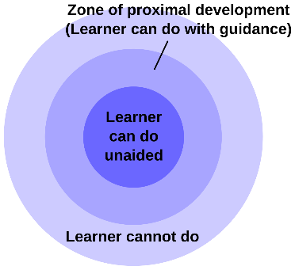
Measurable: It is important to include how the target is to be measured. If the target is vague as in the example above, it is not clear exactly what will be measured. A specific target will make clear the areas of practice that will be evaluated in deciding if the target has been met.
Achievable: As these targets are reviewed each week, they should not be too hard or too large. The Zone of Proximal Development shows where these targets should lie in terms of the experience of the Apprentice.

Relevant The target must be relevant to the Apprentice’s development and also to the learning of the pupils. For example, a target relating to the teaching of Geography would not be relevant if the subject was not on the weekly timetable.
Timed: All targets should be achievable within the following week. Therefore, they need to be bite-sized and within reach of the Apprentice (with a little support if needed). It is important to recognise that targets can be extended into a further week should the Apprentice need further support to achieve it.

Although the `what` element of the target may be identified during feedback following an observation, the `how` can be unpicked during the weekly meeting with the Apprentice. This will make it clear to the Apprentice what they need to do to achieve the target. This is then logged in the Weekly Planner.

What
How

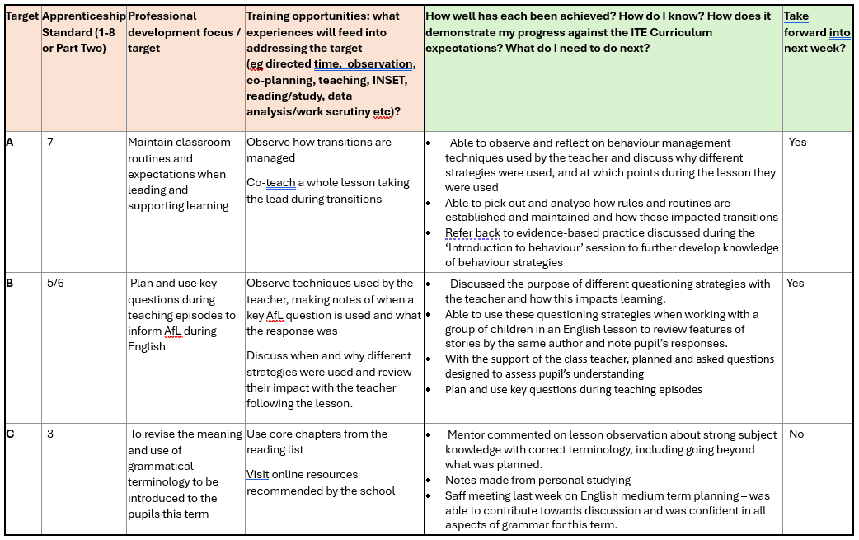
Examples of creating SMART targets can be found in Appendix 1.
Examples of subject-specific targets (informed by the Good Practice Guides) can be found in Appendix 2.

Appendix 1: SMART Targets
The table below looks at examples of targets from weekly planners and considers how they can be changed to meet the requirements of SMART.
During the weekly mentor meeting, the `how` of these targets would need to be established and then included within the Weekly Planner.
Examples of Targets from Weekly Planners | SMART Targets
To improve my subject knowledge in Literacy to enable me to teach the subject with confidence.  This target is very wide – a narrow focus is needed to enable the target to be measured. This will then enable it to be achieved within a short period of time – ideally one week. | Understand how a complex sentence is formed and why it is used in writing.  Here, the target has been narrowed to just focus on one particular aspect of literacy. This makes it easy to measure and to achieve. This should be relevant to what the children are learning in the classroom.
To read a story to the class.  The target is a task rather than indicating an area of professional development. Although it is easy to achieve within a short time, it isn’t clear what learning is to be measured. | To maintain children’s attention whilst reading a story to the class.  This target is specific as it identifies the point of learning - how the Apprentice could retain the attention of the children. Once strategies for this are agreed, it can be more easily achieved and measured.
To use a song to transition from phonics to maths session  Although this is specific, it is a task rather than an area of learning. The task can be measured and achieved, but the learning is not clear. | Develop effective positive behaviour management strategies to support calm transitions.  In this target, behaviour management is targeted but in a specific context – transitions. Strategies could be agreed which are then easily achieved and measured. Relevance of the strategies to the children can also be considered.
Observe a lesson or series of teaching activities in which concrete resources, images and/or textbooks (where appropriate) are used to support and extend children’s learning.  Although this is specific, it is a task rather than a target. By including the context and the actual learning point, it would be more easily achieved and measured. | Understand how concrete resources and images are used to support and extend children’s learning in teaching subtraction in Year 2.  The area of learning is now specific and very clear. The target can be measured through discussion or practice and is achievable within a short time-frame.
Have confidence when dealing with behaviour management issues. Use School Reward System.  This is a wide target for the student to achieve. It is also tricky to define how a student can gain confidence with such a broad area. This would be difficult to measure and achieve within a week – a `bite-sized`, contextualised approach would be more effective. | Identify and practice positive strategies to manage low-level behaviour effectively during collaborative/independent tasks in class.  There is now a narrow focus where the use of relevant strategies by the Apprentice can be observed and measured. The strategies chosen should be relevant to the Apprentice’s class and would therefore be achievable within a short time-frame.

Appendix 2: Examples of Subject-Specific Targets
These targets also include examples of how they could be achieved.
 | Professional development focus / target | Training opportunities: what experiences will feed into addressing the target (eg SBT(s), observation, co-planning, teaching, INSET, reading/study, data analysis/work scrutiny etc)?
 | Model problem-solving in addition using the strategy `think aloud`. | - Observe Maths lead using think aloud and discuss with mentor.  - With mentor, establish steps children need to take to be successful.  - Discuss possible misconceptions with mentor and language to be used.  - Create a script and discuss with mentor.  - Practice in a low-stakes environment (with mentor but without children).
 | Develop understanding of how to identify a scientific question to be answered through practical experimentation.  (This is part of the enquiry-based approach.) | - Organise a discussion with the science lead or mentor.  - Create success criteria to guide own creation of scientific questions.  - Discuss success criteria with mentor and amend as appropriate.  - Practice creating scientific enquiry questions, checking with the Science lead or mentor.
 | Manage the children’s improvisation with musical instruments by introducing non-verbal cues. | - Research the use of non-verbal cues in the playing of music and discuss with mentor.  - Consider ways of introducing these to the children.  - Practice with a piece of music to ensure effectiveness.  - Discuss with mentor before introducing into the classroom.
 | To build context into historical understanding by using timelines to identify the place of Ancient Egypt in world history. | - Ensure own historical understanding is secure.  - Observe a colleague teaching the timeline and discuss with mentor.  - Identify the relevant models and images required, checking with mentor.  - Work with mentor to create a lesson plan.

