Primary PG ITE Mentor Curriculum: 1.4 Understanding trainee knowledge and development – Being a mentor in your school
Arrange a meeting with your ITTCo and discuss the following:
- Key dates for the placement:
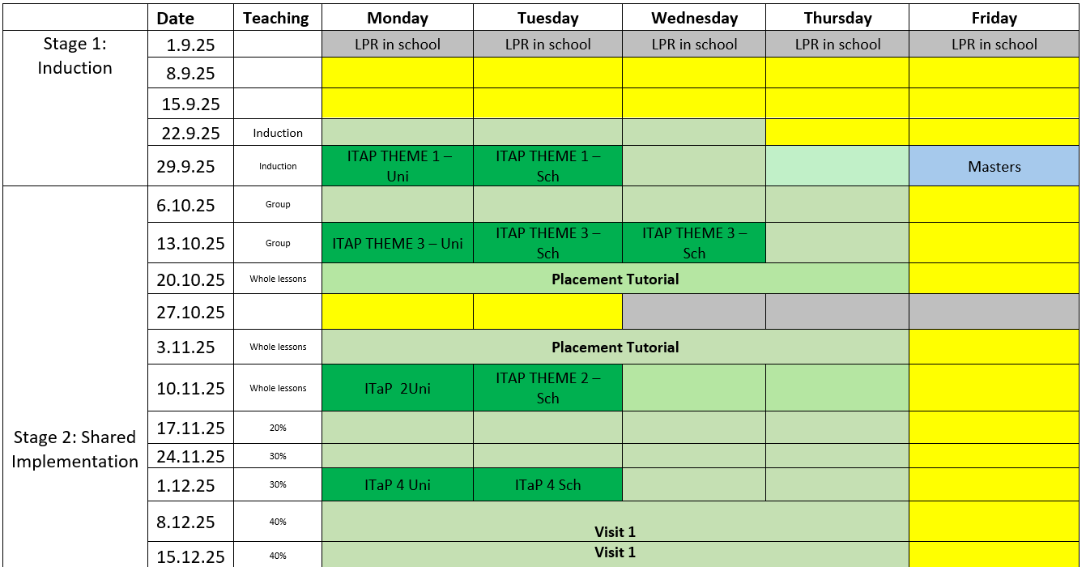
- Share the Placement and Mentor Curriculum handbooks

- Discuss what was agreed during your First Mentor meeting with the RPT and any observations you have made (informal or formal) of your RPT.

- Discuss plans for PPA time this term, especially if this falls on a day when the RPT is at university. How can the RPT still receive good quality planning support, and the workload and wellbeing of the mentor also be protected?

- The ITTCOs involvement in the RPTs training:
  - Organise a time for you to both complete a joint observation of the RPT
  - Ask if the ITTCo would like to attend a weekly mentor meeting
  - Invite the ITTCo to attend the visit from the university tutor
  - Observe the mentor completing a poste lesson discussion to support mentor’s development
  - The importance of copying them into communication with the RPT’s tutor / university
  - What involvement the ITTCo would like in completing the assessments of the RPT (completion of their Assessment of Progress document)

- Share the mentor training curriculum, including the modules for following placements and agree a plan of when and how you can complete these sessions, even if you do not have a trainee at this time.

- Lesson Planning and post lesson discussions
  - Discuss when these will be and when the discussions will take place, considering time for the RPT to reflect.
  - What elements of the post lesson discussion (see 1.2 Implementing the ITE Curriculum) would you like support with, if any?
  - How will you support the RPT in gaining access to everything they need to effectively plan?
  - How will your time be supported in PPA so you still have time to plan your own sessions?

- Design the RPT’s timetable for the following week using the Learning Timetable as a guide, ensuring PPA time is with the mentor, and the mentor meeting is also timetabled and protected.

- Finally, discuss who will support the RPT if the mentor is unwell, and how.

Once you have had this conversation with the ITTCo / Head Teacher, complete the Module completion form on the hub.

