|  |
| --- |
| Institute of Education |
| BA Ed Year 1 Mentor Handbook (serial visits)  2024-25  **C:\Users\gb900635\AppData\Local\Temp\Micklands School 039.jpg C:\Users\gb900635\AppData\Local\Temp\Micklands School 001.jpg C:\Users\gb900635\AppData\Local\Temp\Micklands School 046.jpg**  **Link to BA Ed UoR ITE Mentor Hub -** [**BA Primary Education – University of Reading Mentor Hub**](https://sitesb.reading.ac.uk/ioe-mentoring/sample-page/ba-primary/) |

Contents

1. Welcome and Introduction 2

2 Key Information 2

2.1 Contacts 2

2.2 Mentor Curriculum Outline and Dates 3

2.3 Links & Recommended Reading 4

2.4 Glossary of terms/acronyms 4

3 Partnership Principles and ITE Curriculum Aims 5

4 Roles and Responsibilities 7

5.1 The Reading Partnership Mentor Role 7

5.2 The ITTCo Role 8

5.3 The Supervising Tutor Role 9

5 Being a Reading Partnership Mentor 9

6.1 Mentoring Model 10

6.2 Mentor Qualities 11

6.3 Mentor Knowledge and Skills 12

6.4 The Mentor Mentor-Mentee Relationship 13

6 The RPT Curriculum – how mentors can support 13

6.1 Placement Dates 13

6.2 Intensive Training and Practice (ITaP) 14

6.3 ITaP 1: Building a professional identity for success 14

6.4 The Serial Visits 16

6.5 Inductions 17

7 References 17

# 1. Welcome and Introduction

*‘The human relationship and the conversational learning between mentor and mentee is essentially about learning in a social context and the learning which takes place, because it is social, externalised and internalised, is of a higher order.*

*Coaching and mentoring then reach the parts that other forms of learning just cannot reach’ (Gray et al, 2016, p109)*

Welcome to the University of Reading’s guidance for Reading Partnership Mentors (RPMs). RPMs are a vital component of beginning teachers’ development, and it is our hope that this handbook will provide a comprehensive overview of the RPM’s role. The role of the RPM is a complex one, as you are the conduit between the Reading Partnership Teacher’s (RPT) growing knowledge and understanding of teaching and their application of this in the classroom during their school placements. As such, we have developed a research-informed curriculum for mentors which recognises the importance of the role and develops each RPM’s capabilities as a mentor and competence in supporting each RPT to implement the ITE curriculum.

This handbook consists of information about the ITE Curriculum (what the RPTs learn) and how this should be implemented during school placements, facilitated by RPMs. It details the University of Reading’s Mentor Curriculum, including key information and guidance for RPMs. Please read this handbook in conjunction with programme-specific guides.

Dr Rachel Roberts

Principal Lead Mentor

# 2 Key Information

## 2.1 Contacts

|  |  |  |
| --- | --- | --- |
| **Name** | **Role** | **Email** |
| Dr Rachel Roberts | Principal Lead Mentor,  Deputy Programme Director  Secondary PGCE & English  Subject Lead | r.l.roberts@reading.ac.uk |
| Dr Catherine Foley | Head of ITE | c.m.foley@reading.ac.uk |
| Cara Broadhurst | Professional Programme Director, BA Primary Ed. | c.broadhurst@reading.ac.uk |
| Jane Austen Armstrong  Susan Thomas  Emma Rawlinson | Lead Mentor  Lead Mentor  Lead Mentor | [j.austenarmstrong@reading.ac.uk](mailto:j.austenarmstrong@reading.ac.uk)  [s.thomas5@reading.ac.uk](mailto:s.thomas5@reading.ac.uk)  [e.rawlinson@reading.ac.uk](mailto:e.rawlinson@reading.ac.uk) |
| Liz Henley | Placements Coordinator (arrangements) | [ioeschoolplacements@reading.ac.uk](mailto:ioeschoolplacements@reading.ac.uk) |

## 2.2 Your Mentor Curriculum Outline and Dates

* All the mentor training detailed below needs to be attended or watched / completed, unless you have been told that you have an exemption from some of it because of prior qualifications.
* We will collect evidence that you completed each ‘clump’ of training through very short confirmation forms afterwards.
* We have to supply this evidence of completion to the DfE in order for your school to be able to draw down the funding for your participation in the training, at the end of the year.
* Once you have completed this training cycle, you will not be required to repeat it in following years. The DfE requirement in any following years is that you do six hours of ‘refresher training’.

#### Autumn Term

|  |  |  |  |
| --- | --- | --- | --- |
| **Date** | **Duration** | **Content** | **Format** |
| Released 28th October | 1 hr | **Complete mentor audit and reflection.** | Self-study |
| Thursday78th November | 2 hrs | **Training Module 1** | Online live session  2 to 4pm |
| November | 1 hr | **Related academic reading** | Self-study |
| Released 8th November | 1.5hrs | **Curriculum Familiarisation** | Pre-recorded video +  Handbook reading |
| December | 1 hr | **Reflective meeting with ITTCo** | At your convenience |

#### Spring Term

|  |  |  |  |
| --- | --- | --- | --- |
| **Date** | **Duration** | **Content** | **Format** |
| Released 20th January | 1 hr | **ITAP Training** | Pre-recorded video |
| Released 10th March | 2 hrs | **Training Module 2** | Pre-recorded videos |
| March | 1 hr | **Related academic reading** | Self-study |
| Released 24th March | 1 hr | **The Good Practice Guides** | Pre-recorded video |

#### Summer Term

|  |  |  |  |
| --- | --- | --- | --- |
| **Date** | **Duration** | **Content** | **Format** |
| Tuesday 29th April | 2 hrs | **Training Module 3** | Online live session  4 to 5pm  + Pre-recorded video |
| April/May | 1 hr | **Related academic reading** | Self-study |
| Released 29th April | 1.5hrs | **Curriculum Familiarisation** | Pre-recorded video +  Handbook reading |
| Week/beg 2nd June | 3 hrs | **Tutor Visit (Interim Progress Review)** | Agreed with tutor |
| Post 12th June | 1 hr | **Mentor Evaluation and 500-word written reflection** | Self-study |

Mentors who successfully complete the Mentor Curriculum will qualify for Mentor Certification, which demonstrates that they can:

* Be effective mentors to Reading Partnership Teachers
* Develop the more generic skills of mentoring that will enable them to enhance their career development

Part of gaining the Mentor Certification may involve being invited to speak at one of our Partnership Mentor Training events.

Mentors may also be interested in taking our Master’s Level mentorship module ([EDM190 ‘Developing Mentoring Excellence’](https://www.reading.ac.uk/education/cpd/developing-mentoring-excellence) - 200hrs of study; blended learning; 20 M Level credits). Please contact pgecsecondary@reading.ac.uk for further information.

## 2.3 Links & Recommended Reading

All information for RPMs can be found on your UoR Mentor Hub:

* Mentor handbooks (including this one)
* Training materials: pre-recorded videos, accompanying booklets, recordings of live sessions etc
* Repository of core programme documentation (observation feedback sheet; additional support forms, placement handbook etc.)
* Materials and ideas generated from Lead Mentor work

Quick links to key documents also available online:

* [ITT Early Career Framework - ITTECF (DfE, 2024)](https://assets.publishing.service.gov.uk/media/661d24ac08c3be25cfbd3e61/Initial_Teacher_Training_and_Early_Career_Framework.pdf)
* [The Teachers’ Standards (DfE, 2011)](https://www.gov.uk/government/publications/teachers-standards)
* [Chartered College of Teaching (website)](https://chartered.college/)
* [ITTECF exemplification resources](https://s3.eu-west-2.amazonaws.com/media.nasbtt.org.uk/wp-content/uploads/2021/03/07114405/210315_CCFResources_FINAL.pdf)

## 2.4 Glossary of terms/acronyms

|  |  |
| --- | --- |
| AoP | Assessment of Progress (document that tracks performance on placement) |
| BA Ed | BA Primary Education (the programme name) |
| ECT | Early Career Teacher |
| IPR / FPR | Interim Progress Review / Final Progress Review |
| ITTECF | Initial Teacher Training and Early Career Framework (combines the former Core Content Framework and the Early Career Framework) |
| ITE / ITT | Initial Teacher Education / Initial Teacher Training |
| ITTCo | Initial Teacher Training Co-ordinator (in your school) |
| LHT | ITTECF ‘Learn how to…’ statements |
| LT | ITTECF ‘Learn that…’ statements |
| LM | Lead Mentor |
| PD | Programme Director |
| PS | Professional Studies |
| RPM | Reading Partnership Mentor |
| RPT | Reading Partnership Teacher (trainee) |
| UG | Under-graduate |

# 3 Partnership Principles and ITE Curriculum Aims

Our intent is that RPTs develop into:

* Evidence-informed teachers
* Compassionate professionals
* 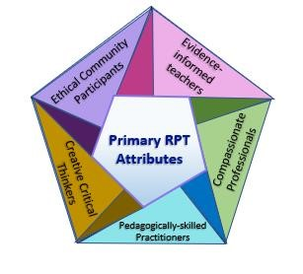Pedagogically-skilled practitioners
* Creative critical thinkers
* Ethical community participants

This is achieved by designing a curriculum that includes and goes beyond the DfE’s ITTECF content, which is broken down into five curriculum strands:

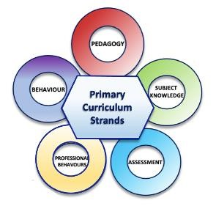

Ultimately these curricular strands lead to achieving the Teachers’ Standards as set out in Table 1.

|  |  |  |  |  |  |  |  |  |  |  |  |
| --- | --- | --- | --- | --- | --- | --- | --- | --- | --- | --- | --- |
| ITE Curriculum Strands | | TS1 | TS2 | TS3 |  | TS4 | TS5 | TS6 | TS7 | TS8 | Part Two |
| Strand A: High expectations and managing behaviour | | √ |  |  |  |  |  |  | √ |  |  |
| Strand B: Pedagogy | |  | √ |  |  | √ | √ |  |  |  |  |
| Strand C: Curriculum | |  |  | √ |  |  |  |  |  |  |  |
| Strand D: Assessment | |  |  |  |  |  |  | √ |  |  |  |
| Strand E: Professional behaviours and wellbeing | |  |  |  |  |  |  |  |  | √ | √ |
| *Table* | *1 Curricular Strands and the Teachers' Standards* | | | |  | |  |  |  |  |  |

The Initial Teacher Training Early Career Framework (ITTECF) is sectioned into ‘Learn that…’ statements and ‘Learn how to…’ statements, ensuring that RPTs learn an appropriate balance of knowledge and skills to equip them to be reflective and resilient teachers. Whilst there is always some overlap, the ‘Learn that…’ statements have been mapped to our Professional Studies and other taught sessions, whilst the ‘Learn how to…’ statements are interwoven through the school-based elements such as the weekly RPT-mentor planning process, school-based tasks (SBTs) and reflective conversations.

In addition to this entitlement, our programme places a particular emphasis on:

* Pastoral support, mental health, wellbeing and resilience for both children and RPTs o This underpins all of our taught sessions and is an integral part of our programme. We deliver specific sessions to support the mental health and wellbeing of RPTs and have a robust Academic Tutor system to support this
* SEND, inclusion and diversity in addition to that which is represented within the ITTECF o All teachers are teachers of SEND and must assume that in their starting point for any provision planned.
* Critical reflection and evidence-informed practice o Everything should be examined critically through a mentor and RPT-owned planning process, including contributions from Generative AI
* Climate and Sustainability Education
* The wider role of the teacher beyond curriculum delivery responsibilities, including what a healthy professional relationship looks like.

The BA Ed curriculum is a complex crafting of experiences and activities, informed by expert input from a wide range of sources and mediated through practise, observation, feedback, discussion, analysis and reflection. The RPTs are supported in becoming critical curriculum thinkers through this input and continue this learning through their school placements.

# 4 Roles and Responsibilities

The RPT is supported in their development principally by three professionals, as set out in Figure 3.

RPT

RPM

(You!)

ITTCo

University

Tutor

## 4.1 The Reading Partnership Mentor (RPM) Role

The Reading Partnership Mentor is responsible for supporting, guiding, and coaching the RPT, so that RPTs can develop and flourish in their classroom practice in their school experiences. This involves providing the RPT with an appropriate timetable, attending relevant University training, and meeting with the RPT each week. The RPM adjusts the training programme in school to meet the individual needs of the RPT, liaising with other members of the school to ensure consistency of approach.

Mentors must communicate regularly with their ITTCo, in order to ensure that the Partnership Agreement is being fully implemented, and that the RPT has every opportunity to engage fully with the ITE curriculum.

The primary responsibilities of an RPM are:

1. Meet with RPT/s to find out about them, creating a robust and mutually respectful, professional relationship.
2. Support the RPTs:
   1. Formally, via a mentor meeting once a week, to be recorded on the Weekly Planner (found in the RPTs ePortfolio which the RPT’s will share with the mentor), setting effective and appropriately challenging targets. (During block placements only.)
   2. Informally, with regular opportunity for reflective discussions, encouraging RPT’s to identify the positives
3. Collaborate with and support RPTs to plan, teach and assess, being mindful of expectations at each stage of training.
4. Observe lessons/group work (at least one per week, if possible) and provide constructive written and verbal feedback.
5. Support RPTs to meet the Assessment Descriptors (see the Mentor Hub) as relevant to the placement / Teacher Standards. Examples of how the RPT’s have done this should be recorded on the ePortfolio claims with a link to the location of the evidence in the ePortfolio (or elsewhere).
6. Support RPTs with their School Based Tasks, drawing on evidence-based research.
7. Assess the RPT, being mindful of their progress through the BA Ed programme and particular expectations for this stage in their training
8. Notify the Supervising Tutor if there are any worries or queries, identifying where progress is a cause for concern and liaise with the RPT, ITTCo and university to devise an appropriate support plan
9. Attend and complete all mentor curriculum sessions as outlined in the Mentor Curriculum Outline.

For the mentor, mentoring provides:

1. A catalyst to reflect upon one’s own practice
2. A way of developing personal and professional skills further
3. Opportunities to network with other professionals
4. Job satisfaction and increased self-esteem
5. New opportunities for career and professional development

## 4.2 The Initial Teacher Training Coordinator (ITTCo) Role

The ITTCo is responsible for organising and quality assuring Initial Teacher Training in the school and are centrally involved in mentor selection. **This involves supporting the University with the implementation of Intensive Training and Practice (ITAP) activities and the Mentor curriculum**. ITTCos are responsible for any arrangements necessary for on-site Progress Reviews (e.g. parking).

The primary responsibilities of an ITT Co-ordinator are:

1. To prepare and implement a policy for ITE within the school.
2. To manage and support the team of mentors, ensuring that they understand the demands of their role and facilitate the sharing of good practice by meeting with them at intervals to share good practice and monitor the progress of the RPTs across the programme.
3. To support the RPTs in their implementation of the University of Reading’s ITE curriculum.
4. To introduce the RPTs to the ethos and working procedures of the school and to key members of staff.
5. To provide training for RPTs on safeguarding and on the relevant school policies, completing all inductions.
6. To arrange for each RPT to be attached to a class and work alongside the class teacher (if not the mentor).
7. To observe each RPT once during their placement and give written feedback on the lesson.
8. To monitor and contribute to the assessment of the RPTs’ progress towards the placement descriptors or The Teachers’ Standards for the award of Qualified Teacher Status as applicable by supporting the assessment and AoP writing process where necessary
9. To support the Quality Assurance monitoring procedures of the university programme and thereby strive for continual improvement in the quality of both school-based and centre-based training.
10. To engage with the DfE’s ITTECF and support the University’s efforts to embed this within the wider curriculum.

## 4.3 The University Tutor Role

The University Tutor is responsible for monitoring, supporting and feeding back to the RPT. They work very much in conjunction with the RPM, even though much of their work is done remotely through reading the RPTs’ e-portfolio. They will visit once during a placement, to observe some teaching but also to talk to you and the RPT about their practice and their progress, as well as to answer questions.

The primary responsibilities of a Supervising Tutor are:

1. Support the Trainee Teacher (RPT) in working towards and achieving the Teachers’ Standards.
2. Visit the Trainee Teacher (RPT) on placement as required.
3. Conduct joint observations of lessons with the Mentor.
4. Contribute to the monitoring and assessment of the Trainee Teacher by giving verbal and written feedback as required by the University.
5. Contribute to the monitoring and assessment of the quality of training and mentoring provided by the Partner.
6. Provide support to the Mentor as required, including arranging additional training for the Mentor.
7. Act as a point of contact between the Mentor, ITTCo and University.

# 5 Being a Reading Partnership Mentor

There are many definitions of mentoring and different mentoring models. A helpful starting point can be to see mentoring as a professional support, whereby mentoring provides:

…a one-to-one relationship between a relatively inexperienced teacher (the mentee) and a relatively experienced teacher (the mentor), which aims to support the mentee’s learning, development and well-being, and their integration into the cultures of both the organisation in which they are employed and the wider profession. (Hobson, 2016, p. 88)

This is a holistic definition that centres mentoring as a relational process and is explicit in the focus on the mentee’s wellbeing, as well as their development as a teacher.

We know how important mentors are in the establishment of beginning teachers’ professional identity and classroom practice, through the range of support mentors provide to induct them into the profession (Hobson, Ashby, Malderez, & Tomlinson, 2009), which speak directly to the attributes that we aim for RPTs to develop in their initial training year, to become: Evidence-informed teachers, Compassionate individuals, Pedagogically-skilled practitioners. Creative critical thinkers and Ethical community participants.

It is important that RPMs recognise their role in the development of these attributes, in order for RPTs to become the value-driven, effective professionals who make positive contributions to education that is the programme’s aim.

In addition, RPMs will benefit from their role: the positive impact you will have on your RPTs; the development of your own learning and reflection on your own practice; and seeing the development of your trainees over time (Hobson, Ashby, Malderez, & Tomlinson, 2009).

## 5.1 Mentoring Model

The University of Reading’s model for mentoring is a developmental model, drawn principally from the work of Clutterbuck (2004). This model recognises the relational process of the mentoring relationship, that potentially incorporates aspects of the counsellor, guide, networker, and coach, as set out below.

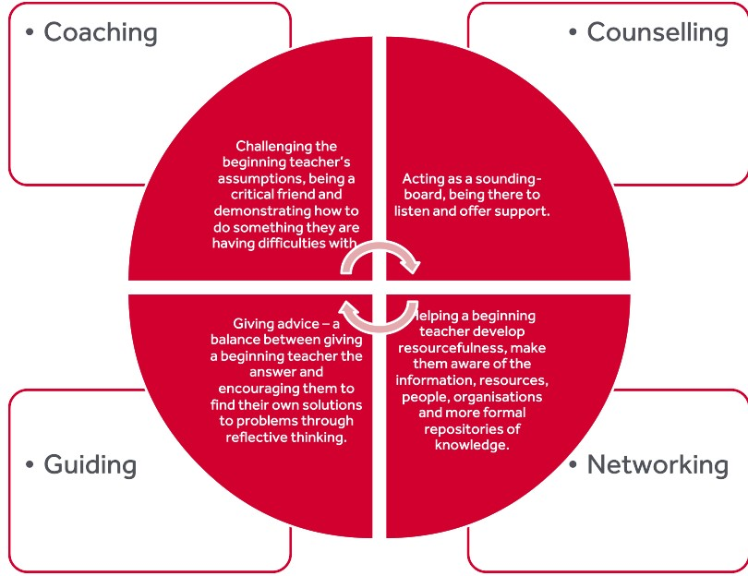

We recognise that, whilst this model aims to be broadly non-directive, RPTs will sometimes ‘benefit from (relatively directive) construction feedback from mentors (Manning & Hobson, 2017, p. 576), and part of the skill of mentoring is assessing when to be more or less directive with your RPT. Mentor training aims to forestall negativity that can be a feature of mentoring if it focuses primarily on performance (‘judgementoring’) so that ‘mentors are first and foremost on the side of – allies, champions and advocates for – their mentees’ (Hobson, 2016, p. 100).

## 

## 5.2 Mentor Qualities

We use the suggested Mentor Standards (DfE, 2016), set out below, to underpin the expectations of the RPM’s role.

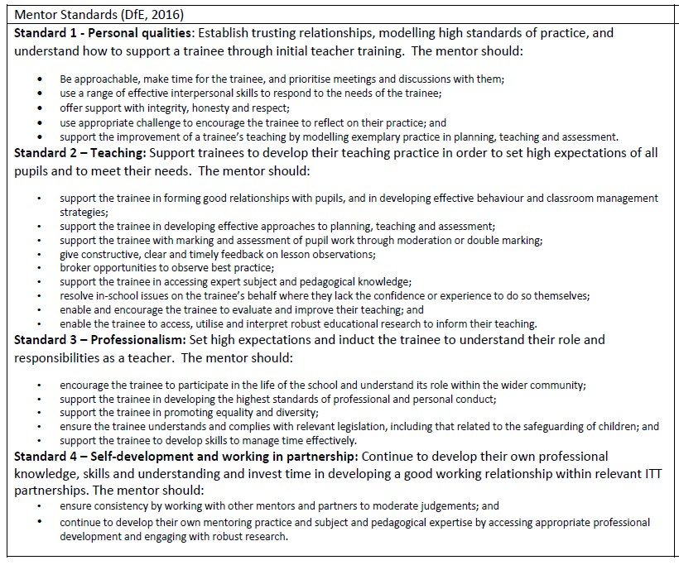

## 5.3 Mentor Knowledge and Skills

Experienced teachers have developed expertise of Pedagogical Content Knowledge (or PCK). This is the overlap between content knowledge and pedagogical knowledge (how children learn), as illustrated here:

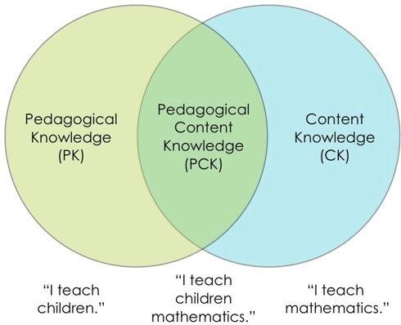

Mentors will draw on several facets of their ‘teacher knowledge’ whilst also needing to knoiw about how they can convey and contextualise this knowledge to their RPT. The table below suggests what these different types of knowledge are depending on whether you are acting in your role as a teacher or as a mentor.

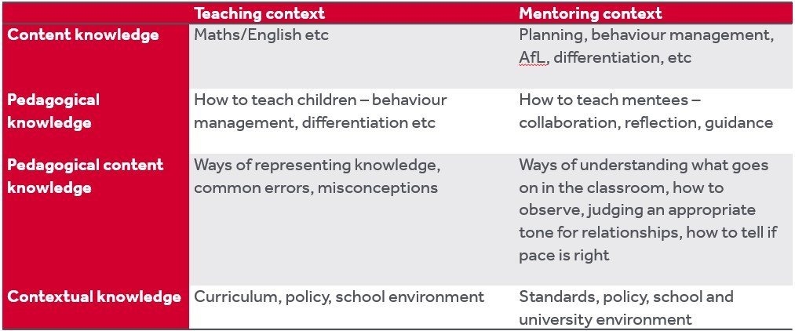

Teachers’ practical knowledge is ‘developed or adjusted by teaching experience and integrates content knowledge, knowledge about students, the curriculum, the specific teaching situation, and pedagogy’ (Zanting, Verloop, & Vermunt, 2003, p. 196); as much of this knowledge is tacit, one of the challenges of mentoring is making *what* you do and *how* you do it explicit for your RPT to learn and develop. RPMs will need to consider themselves as ‘teachers of teaching’ (Grimmett, Forgasz, Williams, & White, 2018, p. 341).

RPMs are asked to complete an audit as part of their training that evaluates your knowledge and skills as a mentor. The tailored mentor training, as set out in section 2.2 above, will develop your knowledge and skills as a mentor, including your knowledge of the [Initial Teacher Training and Early Career Framework](https://assets.publishing.service.gov.uk/media/661d24ac08c3be25cfbd3e61/Initial_Teacher_Training_and_Early_Career_Framework.pdf) (Department for Education) content; part of the mentor’s role is to implement the ITTECF’s ‘Learn how to…’ statements.

## 5.4 The Mentor-Mentee Relationship

The importance of the mentor-trainee relationship is well documented in research (CUREE, 2005; Lord, Atkinson, & Mitchell, 2008) and as a mentor, you have quite a lot of power and influence over your RPT, which shouldn’t be underestimated. As a qualified, experienced teacher, comfortable in your professional environment, much of what you do will seem effortless to a novice. It may seem obvious, but for the RPM-RPT relationship to work, it needs to be positive, bearing in mind the power differential (Roberts, Developing a Mentor-Mentee Relationship, 2020).

Schutz (1994) suggests that positive relationships are dependent on both parties showing that the other is important, competent, and likeable. As an RPM, you need to demonstrate to your RPT that they are *important* by making time for them; that they are *competent* by showing that you believe in them and *likeable* by showing interest in them (Roberts, Developing a Mentor-Mentee Relationship, 2020). These features are reflected in the first Mentor Standard: ‘be approachable, make time for the trainee, and prioritise meetings and discussions with them’ (Department for Education, 2016, p. 11).

The process of becoming a teacher is not as simple as imitation and trying to create a ‘mini-you’ should be avoided: ‘The question is not “how can this student teacher become like me?” but “How can this student teacher learn to start becoming a good teacher?”’ (Goodwyn, 1997, p. 49).

# 6 The RPT Curriculum – how mentors should support

## 6.1 Placement Dates

* **ITaP 1**: Runs w/b 18th Nov. In school all day Thursday 21st Nov and morning of Friday 22nd Nov
* Autumn: 28th Nov and 5th, 12th Dec 2024 (Thursdays)
* Spring: 16th, 23rd, 30th Jan 2025 (Thursdays)
* **ITaP 2**: Runs w/b3 3rd Feb. In school all day Wednesday 5th and Thursday 6th Feb
* Spring: 13th, 27th Feb and 6th, 13th, 20th and 27th March 2025 (Thursdays)
* Summer: 24th Apr and 1st, 8th May 2025 (Thursdays)
* (The 4-week block placement occurs from 12th May to 13th June 2025)

## 6.2 Intensive Training and Practice (ITaP)

An ITaP is a block of ‘Intensive Training and Practice’. The DfE mandate that we provide 6 weeks of this on our programme, additional to school placements. Our RPTs are therefore doing two ITaP weeks per year of their training. The key idea behind ITaP teaching is that the RPTs have a very tight learning focus for the week and that in that time, they learn about, deconstruct, and draft an aspect of teacher practice before enacting it in school. The idea is that the trying it out follows on directly from the drafting done the day before and is followed with immediate reflection back in university to end the week.

The Year 1 ITaP topics are:

ITaP 1: Building a professional identity for success (w/b 18th November):

* **Days in school – all day Thursday 21st Nov and morning of Friday 22nd Nov.**

ITaP 2: Planning and delivering a teaching input (w/b 3rd February)

* **Days in school – Wednesday 5th Feb and Thursday 6th Feb**

We ask that you please keep those days marked in your calendars as days to keep clear of special activities or after school meetings.

## 6.3 ITaP 1: Building a professional identity for success

These are the key learning questions for this first ITaP:

|  |
| --- |
| **Key Learning Content** |
| **Learning Question 1: How can I build positive relationships with the children that I teach? (CCF1.2) (ITTECF 1.7)**  I can:  Make connections with children based on finding out about them  Form positive relationships but maintain healthy boundaries  Demonstrate the values I expect from children, including respect, tolerance and kindness |
| **Learning Question 2: How can I build positive relationships with my colleagues in school? (CCF 1.2)**  I can:  Find out about my school polices and values with a view to guiding my behaviour  Reflect on how I present myself to others  Cultivate a professional identity  Show respect to those contributing to my training |
| **Learning Question 3: How can I make the most effective use of observing colleagues to support my training? (CCF 8.2)**  I can:  Identify a specific observation focus  Articulate how the focus is being enacted in the observed practice  Engage critically with research and use evidence to critique practice (LHT 8g)  Identify how to use this focus to inform my lesson planning (LHT 8d) |
| **Learning Question 4: How can I get the most out of post-lesson observation conversations to inform my practice? (CCF 8.1)**  I can:  Show that I am valuing feedback by demonstrating active listening skills  Engage critically with feedback through exploratory discussion (LHT 8e)  Identify the key aspects of feedback and devise specific ways to act upon these (LHT 8f)  Draw on research and evidence to support conclusions about practice (LHT 8g) |

Please read the boxes below to understand what we need the RPTs to do in school during ITaP 1 and your role in facilitating it

|  |
| --- |
| **Thursday, 21st November: School-based Activities**  On their first day, the RPTs need to complete the following activities. We have given suggested timings, but these are flexible so please organise them as fits with your school day. The ones in bold are activities that require your particular input or support. |
| 1. Getting to know children:  * Your RPTs will spend time in the classroom while you teach. Their focus will be on learning the children’s names, familiarising themselves with classroom routines, and supporting children’s learning as appropriate. * *Suggested timing: from start of day to play time.*  1. Getting to know year group colleagues:  * Please introduce your RPT to other colleagues within your year group team. * *Suggested timing: at play time.*  1. **‘This is Me’ activity and ‘getting to know you’ games:**  * **Your RPTs will have planned a session to introduce themselves to the class and play games/sing songs to build rapport with the class.** * **Time required: ~1 hour.** * **Please observe this session and be ready to provide general feedback afterward.** Do not use an official observation pro-forma. Focus your notes on the following:   + Volume   + Tone of voice   + Body language/enthusiasm   + Appropriateness/pitching of RPT content   + RPTs’ ability to make links with chln’s lives * ***Suggested timing: after play time*.**  1. RPT’s reflections on the “This is Me” session:  * Your RPT will write some personal reflections. The best place for them to do this is in a space close to the classroom, where they can still see comings and going but are not overly distracted from their writing. * *Suggested timing: in the afternoon.*  1. Getting to know wider school staff:  * Your RPTs will go and introduce themselves to wider school staff, e.g. office staff, caretakers etc. Please facilitate these introductions by warning all colleagues in advance that two new trainees will be joining your school family on Thursday. * *Suggested timing: in the afternoon.*      1. **Conversation with your RPTs:**  * **This should happen *after* the “This is Me” session, and have two elements:**   + **You and they get to know each other better.** Use the introductory emails they sent on Monday as a jumping off point for finding out a bit more about your RPTs. You could include questions such as’ What can you tell me about yourself as a person outside teaching?’ and ‘What are you looking forward to and what concerns or worries do you have about this placement?’ Tell them a little about you too.   + **A post-activity reflective conversation**. They will be practising their professional listening skills during this. It is their very first activity on their very first day in school, so we want you very much to focus on the positive elements of what they did. However, do ask one question to get them *thinking* about improvement: ‘Is there anything that you would prefer to do differently if you had the time again?’ * **Time required: ~45 minutes.** * ***Suggested timing: after school.*** |

|  |
| --- |
| **Friday, 22nd November (Morning): School-based Activities** |
| 1. Observation of mentor teaching:  * Your RPT will observe you teaching a lesson with a focus on how you maintain positive relationships while managing behaviour. * *Suggested timing: during the first lesson.*  1. Evaluation of observation:  * Your RPT will use literature to reflect on their observation of you, in a quiet space. * *Suggested timing: after the first lesson*  1. **School tour and discussion with Head Teacher or Senior Leader:**  * **Please coordinate with the head teacher or a senior leader to arrange for them to take the RPTs on a tour of the school.** * **During the tour, the RPTs will ask the senior leader about the school’s values and ethos.** * ***Suggested timing: late morning*** |

## 6.4 The Serial Visits

The aims of the placement are for the RPTs to:

* Become familiar with the working practices, expectations and ethos of a school ‘from the inside’.
* Establish positive relationships with children and staff in advance of their block School Experience.
* Develop their understanding of Child Development by relating theory to practice.
* Develop their understanding of other elements covered in their university sessions, including the key learning points from the ITTECF that are specified in the School-based Tasks table (in the SE Handbook, page 9).
* Become more skilled at classroom observation and the important reflection that follows this.
* Develop professional teamwork skills through working alongside a partner.

To this end, they have been asked to do two tasks per visit. **These tasks are outlined in the RPTs’ School Experience Handbook from page 9 onwards. Please read these.**

The tasks are designed to consolidate learning done each week in university and help the RPTs see how it looks in action. They are also heavily underpinned by the ‘Learn how to…’ statements in the ITTECF. We have listed the relevant learning statements next to each task so you can understand the key points we intend them to think about. If you feel unsure about any of this content, you can contact us - Cara Broadhurst, Programme Director or any of the Lead Mentors (email addresses at the front of this handbook) – or look up the learning statement in context in the ITTECF next to the ‘Know that…’ statements. [The ITTECF (DfE, 2024)](https://assets.publishing.service.gov.uk/media/661d24ac08c3be25cfbd3e61/Initial_Teacher_Training_and_Early_Career_Framework.pdf)

Although it is obviously ideal to do the tasks on the dates listed, we do know that things may happen that make this difficult. The RPTs therefore know they will have to be flexible in these instances. What we ask is that you discuss with them:

* If the task can be swapped with another one that can be more easily done that day.
* If they could do something slightly different that will still allow them to learn the same skills.
* How they can fit the task in on a different visit.

Please note the Mentor Role column, which flags up any facilitation or arranging you may need to do for a task but also outlines the key messages to get across to your RPTs in the discussions that take place.

## 6.5 Inductions

Your RPT needs four policy inductions. An induction usually means sending the policy or a link electronically to the RPTs before having a short briefing to cover it’s key points, but do please be mindful of RPTs with specific learning needs who process information better on paper or that it may be better for the briefing to precede the policy reading, to break down quantities of information.

It would usually be the school ITTCo who carries out the inductions, but they can be delegated to you or anyone suitable.

Please give inductions into your school’s:

* Child protection and safeguarding policy
* GDPR policy
* Staff Code of Conduct
* Health and Safety policy

Please note that all trainees have read and made notes on KCSIE before starting in your school.

# 7 References

Clutterbuck, D. (2004). *Everyone Needs a Mentor: Fostering Talent in Your Organisation.* London: Chartered Institute of Personnel and Development.

Connollly, S., Bates, G., & Shea, J. (2020). "First meetings": constructive first encounters between pre-service teachers and their mentors. *International Journal of Mentoring and Coaching*, 411-426.

CUREE. (2005). Retrieved from www.curee.co.uk/resources/publications/national-framework-mentoring-coaching

Department for Education. (2016, July). *https://assets.publishing.service.gov.uk/government/uploads/system/uploads/attachment_data/file/536891/Me ntor_standards_report_Final.pdf.* Retrieved from https://assets.publishing.service.gov.uk/government/uploads/system/uploads/attachment_data/file/536891/Me ntor_standards_report_Final.pdf

Department for Education. (2019). *https://assets.publishing.service.gov.uk/government/uploads/system/uploads/attachment_data/file/974307/ITT_ core_content_framework_.pdf.* Retrieved from https://assets.publishing.service.gov.uk/government/uploads/system/uploads/attachment_data/file/974307/ITT _core_content_framework_.pdf

Ellis, N., Alonzo, D., & Nguyen, H. (2020). Elements of a quality pre-service teacher mentor: A literature review. *Teaching and Teacher Education*, 1-13.

Ferrier-Kerr, J. (2009). Establishing professional relationships in practicum settings. *Teaching and Teacher Education*, 790797.

Gibbs, G. (1988). *Learning by Doing: A guide to teaching and learning methods.* Oxford: Oxford Further Education Unit.

Golder, G., Keyworth, A., & Shaw, C. (2020). Ch 1: Models of mentoring. In D. H. (ed.), *Mentoring English Teachers in the Secondary School* (pp. 5-16). Abingdon: Routledge.

Grimmett, H., Forgasz, R., Williams, J., & White, S. (2018). Reimagining the role of mentor teachers in professional experience: moving to I as fellow teacher educator. *Asia-Pacific Journal of Teacher Education*, 340-353.

Hobson, A. (2016). Judgementoring and how to avert it: introducing ONSIDE Mentoring for beginning teachers. *International Journal of Mentoring and Coaching in Education*, 87-110.

Hobson, A., Ashby, P., Malderez, A., & Tomlinson, P. (2009). Mentoring beginning teachers: What we know and what we don't. *Teaching and Teacher Education*, 207-216.

Jones, M., & Straker, K. (2006). What informs mentors’ practice when working with trainees and newly qualified teachers? An investigation into mentors’ professional knowledge base. . *Journal of Education for Teaching, 32*(2), 165-184.

Lord, P., Atkinson, M., & Mitchell, H. (2008). *Mentoring and Coaching for Professionals: A Study of the Research Evidence.* Retrieved from www.nfer.ac.uk/mentor-and-coaching-for-professionals-a-study-of-the-research-evidence

Manning, C., & Hobson, A. (2017). Judgemental and developmental mentoring in further education initial teacher education in England: mentor and mentee perspectives. *Research in Post-Compulsory Education*, 574-595.

Maynard, T., & Furlong, J. (1995). Learning to teach and models of mentoring. In T. K. Mayes, *Issues in Mentoring* (pp. 1024). London: Routledge.

Roberts, R. (2020). Developing a Mentor-Mentee Relationship. In D. Hickman, *Mentoring English Teachers in the Secondary School* (pp. 36-49). Abingdon: Routledge.

Roberts, R. (2020). Holding weekly debriefs. In D. Hickman, *Mentoring English Teachers in the Secondary School* (pp. 126139). Abingdon: Routledge.

Roberts, R. (2020). Observing beginning teachers' lessons. In D. Hickman, *Mentoring English Teachers in the Secondary School* (pp. 112-125). Abingdon: Routledge.

Schutz, W. (1994). *The Human Element.* San Francisco, CA.: Jossey-Bass.

Shulman, L. (1986). Those who understand: Knowledge growth in teaching. *Educational Researcher, 15*(2), 4-14.

Zanting, A., Verloop, N., & Vermunt, J. (2003). Using interviews and concept maps to access mentor teachers’ practical knowledge. *Higher Education, 46*, 195-214.

# 9 Appendices

# Appendix A: Questions for your first mentor meeting

1. What would you describe as your strengths and weaknesses? Let’s have a look at your Initial needs / AoP document to identify where we can develop these.
2. How are you at managing your time - is this something you feel you need to develop?
3. What do you expect to gain from this placement?
4. What boundaries do we need to set for communicating with each other? Are you okay with phone/email/text? When? When not? How quick does my response need to be?
5. Do you want the opportunity to speak to me briefly every day about what you’re doing or are you happy to keep it to the weekly mentor meeting?
6. How were you mentored on your previous placement? Tell me about what went well and what could have been better, remembering to remain professional in your responses.
7. What can you tell me about yourself as a person outside teaching?
8. What are you looking forward to and what concerns or worries do you have about this placement?
9. What information do you think you need from me to start this placement off as well as you can? What do you expect of me throughout the placement?
10. What kind of pedagogical approaches and techniques have you had the opportunity to experiment with in your first placement? Is there a particular pedagogical approach that you would like to develop in this placement?
11. What would you like to know about the curriculum/SOWs that we use in this school? (Connollly, Bates, & Shea, 2020, p. 419)