Using Lead Mentors to support mentors
(For LMs/PDs/university tutors/Subject Leads/ITTCos)
The Lead Mentor role has a range of duties, as outlined in the chart below:
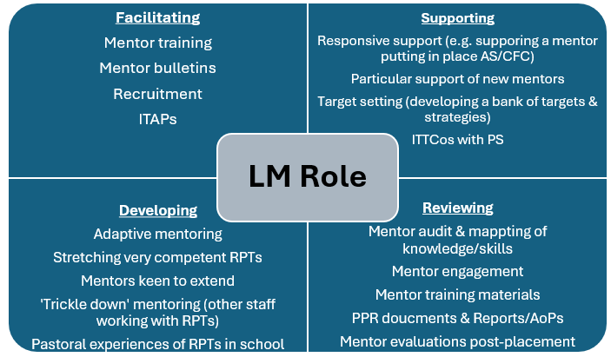

Has an area of mentoring practice that requires development been identified by the Lead Mentor (e.g. via the Mentor Audit) or the PD/ITTCo/tutor/SL (e.g. via PPRs) or the mentor themselves (e.g. via Mentor Audit)?

No
Yes

LM to organise an informal ‘check-in’ meeting with mentor (PD/ITTCo/tutor/SL to prompt LM if they identify a need).
Does the LM feel that the issue/context might require further understanding (if it is complex/sensitive)?

No
Yes
LMs to ‘check-in’ periodically through out the year and offer an occasional ‘office hour’ when mentors can drop in for a conversation.
2. Involve the ITTCo, by sharing your concerns. Discuss with ITTCo and university team how you can help develop the mentor or support the situation.
1.Contact programme team at the university (Principle LM/PD etc.)
No
Yes
4. Agree a timeframe to review. Does the LM feel that the situation needs escalating?
3. LM to share tools and strategies that might support them, looking at examples together.
2. LM to conduct a supportive meeting (using handbook/programme guidance, look at relevant programme expectations together if helpful).
(If the conversation might be difficult, prepare for this using additional guidance provided.)
1. LM to consult PD/ITTCo/tutor/SL prior to meeting with mentor.
LM to follow up with the mentor/ITTCo/university staff as appropriate to review whether practice has developed.
Follow up with the mentor/ITTCo/university team as appropriate to review whether practice has developed.

