# Primary PG ITE Mentor Curriculum: 1.4 Understanding trainee knowledge and development  – Being a mentor in your school

Arrange a meeting with your ITTCo and discuss the following:

1. Key dates for the placement:

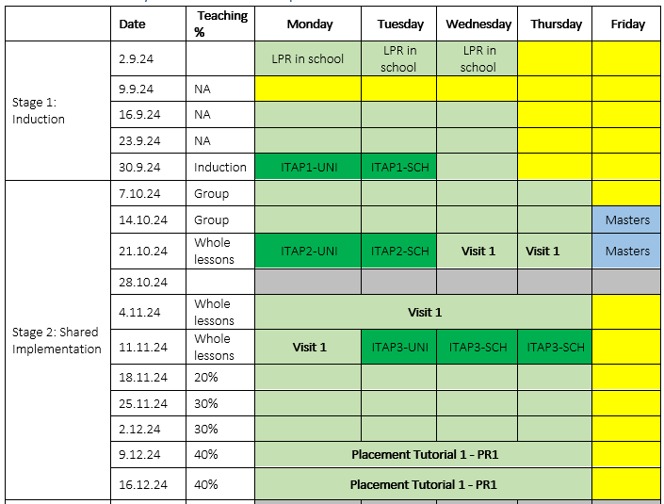

1. Share the Placement and Mentor Curriculum handbooks
2. Discuss what was agreed during your First Mentor meeting with the RPT and any observations you have made (informal or formal) of your RPT.
3. Discuss plans for PPA time this term, especially if this falls on a day when the RPT is at university. How can the RPT still receive good quality planning support, and the workload and wellbeing of the mentor also be protected?
4. The ITTCOs involvement in the RPTs training:
   1. Organise a time for you to both complete a joint observation of the RPT
   2. Ask if the ITTCo would like to attend a weekly mentor meeting
   3. Invite the ITTCo to attend the visit from the university tutor
   4. Observe the mentor completing a poste lesson discussion to support mentor’s development
   5. The importance of copying them into communication with the RPT’s tutor / university
   6. What involvement the ITTCo would like in completing the assessments of the RPT (completion of their Assessment of Progress document)
5. Share the mentor training curriculum, including the modules for following placements and agree a plan of when and how you can complete these sessions, even if you do not have a trainee at this time.
6. Lesson Planning and post lesson discussions
   1. Discuss when these will be and when the discussions will take place, considering time for the RPT to reflect.
   2. What elements of the post lesson discussion (see 1.2 Implementing the ITE Curriculum) would you like support with, if any?
   3. How will you support the RPT in gaining access to everything they need to effectively plan?
   4. How will your time be supported in PPA so you still have time to plan your own sessions?
7. Design the RPT’s timetable for the following week using the Learning Timetable as a guide, ensuring PPA time is with the mentor, and the mentor meeting is also timetabled and protected.

1. Finally, discuss who will support the RPT if the mentor is unwell, and how.

Once you have had this conversation with the ITTCo / Head Teacher, complete the Module completion form:

<https://forms.office.com/e/3RV1aKLTTM>